**Email Etiquette**  
Email is a **Fast** and **Effective** way to communicate with your employer and colleagues.  Because email use is so prevalent in the workplace, it is important that employees are familiar with email etiquette and guidelines.

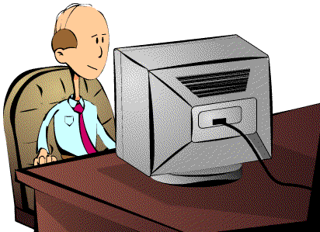

Let's Begin Our First Topic!  
  
Managing Emails  
  
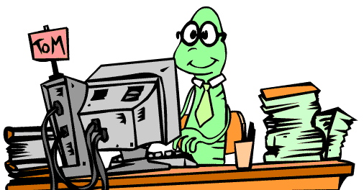

* **Deleting and Filing** your emails regularly helps keep you organized and helps optimize valuable memory.
* Remember that you may need to **Empty** your deleted emails folder.
* If you are unsure about how to delete emails or optimize your computer's memory, be sure to talk to your **IT Department**.

Why do we need email etiquette at work?  
  
  
  
A company needs to implement etiquette rules for the following three reasons:

* **Professionalism:** by using proper email language your company will convey a professional image.
* **Efficiency:** emails that get to the point are much more effective than poorly worded emails.
* **Protection from liability:** employee awareness of email risks will protect your company from costly lawsuits.

**Let's learn more about**

**Limiting Your Emails.  
  
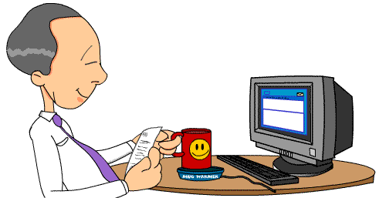**

* Keep emails **Short** and to the point.
* Email can be **Distracting**. Be aware of how much time you spend emailing each day.
* Avoid getting caught up in "chatty email." Try to keep messages **Professional**.

**Read Over these Email Tips!**

* Use proper spelling & grammar
* Do not attach unnecessary files
* Do not write in CAPITALS
* Read the email before you send it
* Use abbreviations and emotion icons sparingly
* Do not use emails to discuss confidential information
* Avoid long sentences
* Do not forward chain letters
* Do not send or forward emails containing defamatory, offensive, or obscene remarks.
* Do not reply to spam